All of the available capabilities must be dragged to a location. The order in which they are placed in sections that require multiple capabilities does not matter. You are putting the capabilities in the locations that they BEST fit the device they are supporting with control (s).

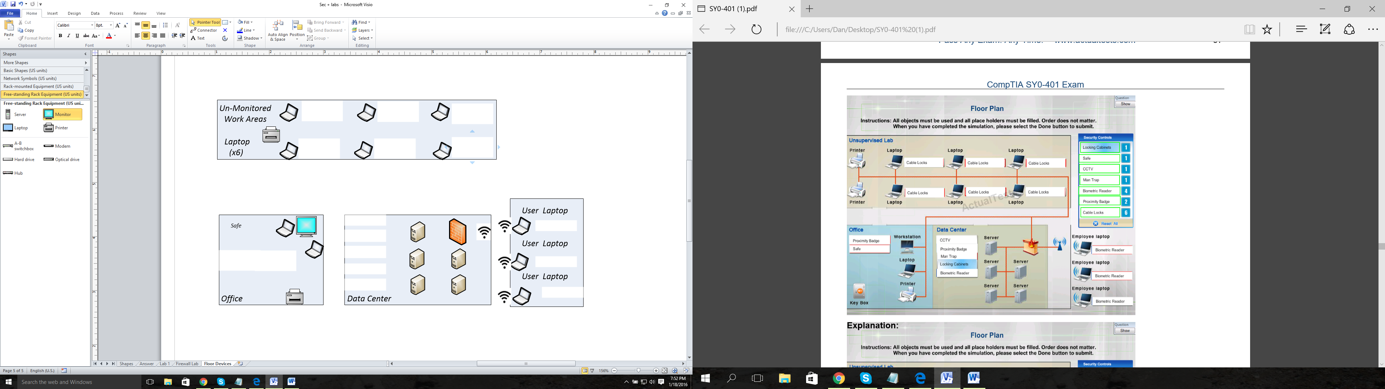

Main Facility

Proximity Badge

Proximity Badge

Mantrap

Cable Locks

Cable Locks

Cable Locks

Cable Locks

Cable Locks

Cable Locks

Locking Cabinets

Biometric Reader

Biometric Reader

Biometric Reader

Biometric Reader

CCTV

Safe